Domus Lighting Website Brief 2015

Domus Lighting | 29-31 Richland St Kingsgrove NSW 2208

Commercial in Confidence

Francis Care

2015

Contents

Website Brief 2

Company Background 2

Website Purpose 2

Look and Feel 2

Website Structure 3

Home Page 3

Suggested Structure 3

Header 4

Product Hierarchy 4

Primary Navigation 4

Featured Products 7

News 7

Dealer Locator 8

Contact Us Form 8

Footer 9

Dealer Locator 9

About Us 9

Product List Page (2nd Product hierarchy) 10

Product List Page (3rd Product hierarchy) 10

Individual Product Page 10

# Website Brief

## Company Background

Domus Lighting is a B2B wholesaler, distributor and importer of quality LED and other lighting products that was founded in 1961.

As a B2B company, there are elements of this website which need to appeal to an end consumer whilst others that should appeal to our customers who order from us.

## Website Purpose

The purpose of the website is as follows:

1. A Marketing tool for end consumers to drive demand (for new and existing products) upwards to their local stockist/supplier.
2. To allow end users to quickly and easily find their nearest stockist
3. To allow our clients to find products quickly including the following information:
   1. Technical datasheets
   2. Installation Manuals
   3. High Quality Product Images
4. To allow our clients to quickly and easily place orders online that flows through to our ERP system
5. To allow both end consumers and stockists to contact Domus for the following:
   1. Sales Enquiries
   2. Warranty
   3. Account Opening Inquiries

## Look and Feel

The website needs to move away from a dark background and move toward a light, white, clean, fresh new image perhaps with a subtle feeling of being energy efficient.

The website needs to balance being beautiful, architectural and artistic with the functionality of displaying products and allowing users to find information quickly and easily.

# Website Structure

# Home Page

### Suggested Structure

|  |  |  |
| --- | --- | --- |
| Header | | |
| Primary Navigation | | |
| Slider | | |
| Featured Products | | |
| Blog News | Dealer Locator | Contact Us Form |
| Footer | | |

Or alternatively:

|  |  |  |
| --- | --- | --- |
| Header | | |
| Primary Navigation | | |
| Slider | | |
| Featured Products | | Contact Us Form |
| Blog News | Dealer Locator |
| Footer | | |

You may want to think about having a tile for project gallery or catalogues/downloads also?

**If you can suggest an alternative to any of the ideas above, please feel free to do so.**

### Header

The header needs to have the following:

1. Logo and brand on the top left
2. Contact Phone Number **02 9554 9600 prominent in the header**
3. Search Bar with the following wording pre-loaded: ‘item #, keyword, description’
4. Store Locator with the ability to enter a postcode or suburb directly from the header (this can be via hover or having it static)
5. Login with hover over for login and password or wishlist
6. Secondary Navigation Menu (this will contain information that is fairly static on the site):
   1. About Us
   2. Project Gallery
   3. Catalogues
   4. Downloads
   5. FAQ
   6. Contact Us

After a client logs in, the following should also be visible:

1. Checkout with number of products preview
2. Quick Order button

### Product Hierarchy

A SKU product can have 4 hierarchy levels e.g

1. Lighting
   1. Downlights
      1. Deco Series
         1. 20521 – DECO 13W DOWNLIGHT 3000K

### Primary Navigation

The Primary Menu will have 3 main categories of products: Lighting (the biggest), Ceiling Fans and Bathroom Heaters.

The primary menu navigation will only go to the third level of product hierarchy (see above).

This is the most important menu of the website and it should be a mega menu with a preview image (on the right hand side within the menu) displaying a preview image of the product range. It would be good to see a mock-up of the lighting range menu at least to see how all this information will look on a menu. For an example of what we’re looking for on the mega-menu look at say [www.target.com.au](http://www.target.com.au) or [www.myer.com.au](http://www.myer.com.au)

* **Lighting**
  1. Downlights
     1. Deco Series
     2. Tek-10 Series
     3. Neo Series
     4. DLK Series
     5. Deep Series
     6. Retro Series
     7. Splash Series
     8. Scoop Series
  2. Downlight Accessories
  3. Oysters
     1. Disc Series
     2. Tab Series
  4. Panel Lights
     1. Panel 101 Series
     2. Panel 200 Series
     3. Panel 303 Series
     4. Panel 306 Series
     5. Panel 312 Series
     6. Panel 606 Series
     7. Panel Accessories
  5. Track Lights
     1. Jet Series
  6. Picture Lights
  7. Step Lights
     1. Ixis Series
     2. Step Series
     3. Blade Series
     4. Mini Eye Series
     5. Slide 1 Series
     6. Slide 2 Series
     7. Slide 3 Series
     8. Chill Series
     9. Allure Series
     10. Me Series
     11. Mini Rectangle Series
     12. Maxi Rectangle Series
     13. Mini Square Series
     14. Maxi Square Series
     15. Rondo Series
     16. Quad Series
     17. Block Series
  8. Profiles
     1. Bobby Bloc
     2. Bobby Bloc Maxi
     3. Bobby Curve
     4. Bobby – T
     5. Edge
     6. Infinity
     7. Line-46
     8. Luma Line
     9. Luma Line 2
     10. Nova Line Recessed
     11. Nova Line Surface Mounted
     12. Omega 35
     13. Opti Line Recessed
     14. Opti Line Surface Mount
     15. Q-Line Mini
     16. Quad Line Mini
     17. Shadow Line
     18. V-Line
  9. Power Supplies
     1. 350mA Constant Current
     2. 700mA Constant Current
     3. 12V Constant Voltage
     4. 24V Constant Voltage
     5. Accessories
  10. Controllers
  11. Cabinet Lights
      1. Astra Series
      2. Power Puk 01
      3. Power Puk 02
      4. Power Puk 03
      5. Power Puk 04
      6. Power Puk 05
      7. Power Puk 06
      8. Power Puk 07
      9. Power Puk 08
      10. Power Puk 09
      11. Power Puk 10
      12. Power Puk 11
      13. Power Puk 12
      14. Power Puk 13
      15. Power Puk 14
      16. Power Puk 15
      17. Power Puk 16
  12. Garden Lights
      1. Terra Series
      2. Emit Series
      3. Elite Spike Series
      4. ME Series
      5. LED 520 Series
      6. BL100 Series
  13. Spot and Floodlights
      1. Muro Series
  14. Pendants
      1. Pandora
      2. Carbon
      3. Scroll
      4. Alpine
  15. Inground Lights
      1. Vivid Series
      2. Plate Series
      3. Fusion 2 Series
      4. Star Series
      5. Laser Series
      6. Point Series
      7. Point 2 Series
      8. Thread Series
      9. Thread 2 Series
      10. Shine Series
      11. Twilite Series
      12. Deka Series
      13. Modula Series
  16. Lamps
      1. Retro 10
      2. MR16
      3. GU10
      4. G4
      5. Tube Lamps
  17. Polycarbonate Range
      1. Polycarbonate Wall Lights
      2. Polycarbonate Ceiling Lights
      3. Polycarbonate Bunkers
  18. Traditional Exteriors
      1. Monaco Series
      2. Lisbon Series
      3. Siena Series
      4. Vienna Series
      5. Chester Series
      6. Paris Series
      7. Avignon Series
      8. Hannover Series
      9. Turin Series
      10. Accessories
* **Ceiling Fans**
  1. Avatar Series
  2. Windy Series
  3. Brisk Series
  4. Viento Series
  5. Accessories
* **Bathroom Heaters**
  1. Test 1 Series
  2. Test 2 Series
  3. Test 3 Series
  4. Accessories

### Featured Products

* The featured products area should contain links to certain product series ie. level 2 in the product hierarchy.
* The user will be able to filter these on: lighting, ceiling fans and bathroom heaters.
* The user will be able to click to the left or right to view more featured products

### News

This will be a scrolling news with latest news information etc.

### Dealer Locator

The dealer locator should have a stylised image of Australia with a search bar to enter a postcode or suburb. In addition, below that should be the following:

* Link to view all our stockists
* Link to view online stockists

### Contact Us Form

This should be a dynamic form that changes based on a dropdown menu:

1. Product Enquiry
2. Open an Account
3. Warranty request
4. Technical Enquiry

The following Fields will display depending on the selection:

**Product Enquiry**

1. Name *
2. Email address *
3. Contact Phone Number *
4. Product
5. Message *

* mandatory field

**Open an Account**

1. Name*
2. Email Address*
3. Contact Phone Number*
4. Business Name*
5. Message*

* mandatory field

**Warranty Request**

1. Name
2. Email Address
3. Contact Phone Number
4. Product
5. Message

* mandatory field

### Footer

The footer should contain the following:

1. Sitemap with links to the following:
   1. Home
   2. About Us
   3. Contact Us
   4. News
   5. FAQ
   6. Wishlist
2. Subscribe to the Newsletter
3. Follow (social media)
   1. Facebook
   2. Twitter
   3. Youtube
   4. Google +
4. Contact Phone Number prominent: 02 9554 9600
5. Logos section on the far right hand side:
   1. ISO9001 Accreditation
   2. Lighting Council of Australia
   3. IES Australia
   4. Homelight logo (refer to brand guidelines)
   5. Evergreen logo (refer to brand guidelines)
6. Copyright message 2015
7. A third navigation menu for the following:
   1. Privacy Policy
   2. Disclaimer
   3. Help

# Dealer Locator

The dealer locator page should operate very similar to the following:

<http://www.martecaustralia.com.au/dealerlocator/>

You should be able to search via postcode, suburb and select a radius with a google map and list view of your results.

# About Us

No real requirements – perhaps some links on the left hand side such as:

1. History
2. Team
3. Mission Statement
4. Values

Perhaps something like:

<http://brightgreen.com/au/our-team>

# Product List Page (2nd Product hierarchy)

The product list page (2nd product hierarchy) should contain the following:

1. Links to the 3rd product categories via a clickable image. E.g if you click on Downlights then you should have large clickable image links for Deco Series, Neo Series, Scoop series etc. (refer to Primary Navigation menu above).

# Product List Page (3rd Product hierarchy)

The product list page (3rd product hierarchy) should contain the following:

1. Filters down the left hand side for things like the following:
   1. Lamp Colour
   2. Wattage
   3. Voltage
   4. Cut out size etc etc
2. List view or grid view option (by default this will be grid view)
3. Previews of each SKU product with an image, SKU number etc

# Individual Product Page

Product page should contain the following information:

1. Breadcrumbs at the top of the page
2. Large images with zoom when hover over and small thumbnails to change the images
3. Large Title
4. Area for Description
5. Tabs area with the following:
   1. Specifications
   2. Downloads
6. Customers also viewed section
7. Related products section
8. SKU Number
9. Write a review area with star rating indicating average reviews (out of 5)
10. Share section for email, social media etc.

Something along the lines of this:

<http://sana9preview.cloudapp.net/en-us/computers/notebooks/hp-envy-dv7-7230eg-sc10004?returnurl=%2fen-us%2fcomputers%2fnotebooks%2f%23sc10004>

# Mood Board

1. [www.artemide.com.au](http://www.artemide.com.au)

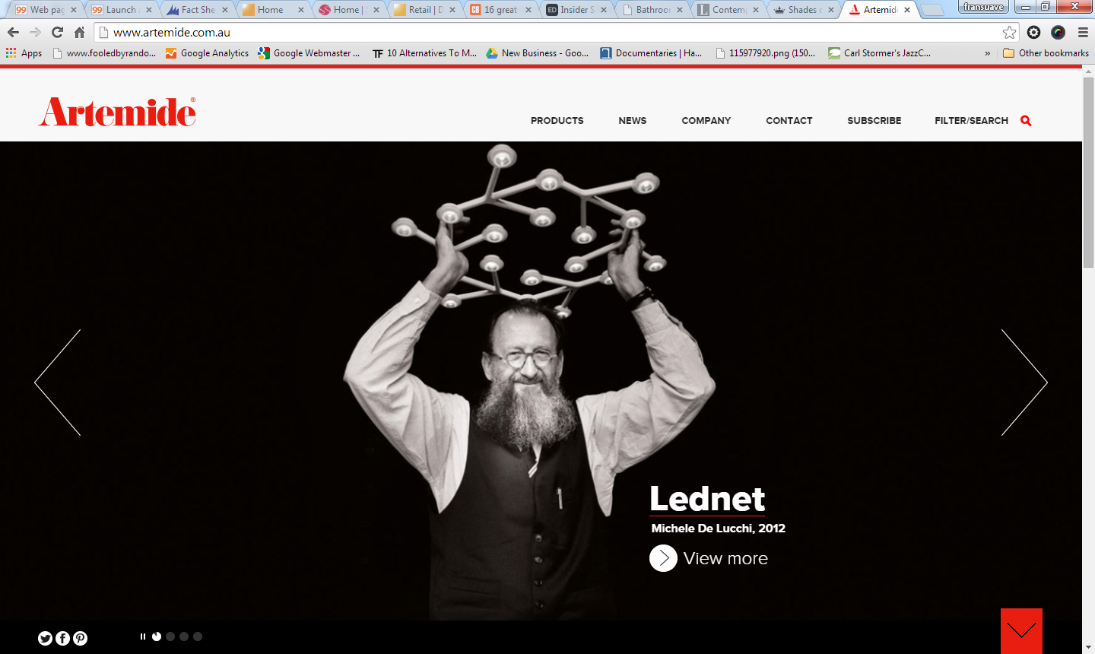

Elegant, artistic, simple, frameless, nice photography.

1. [www.martecaustralia.com.au](http://www.martecaustralia.com.au)

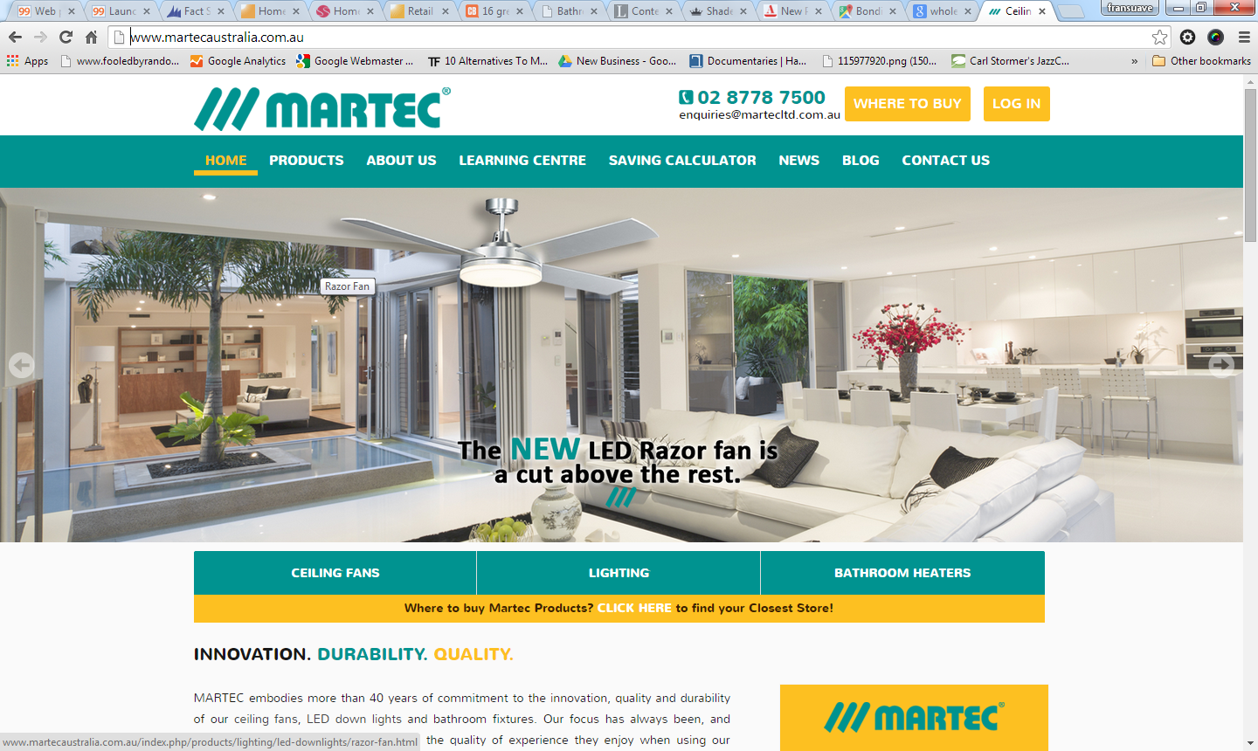

* This is one of our competitors – we would like to ensure our website looks and feels better than this.
* Similar layout and format to what we’re after – drive sales to the stockists/dealers.

1. [www.commbank.com.au](http://www.commbank.com.au)

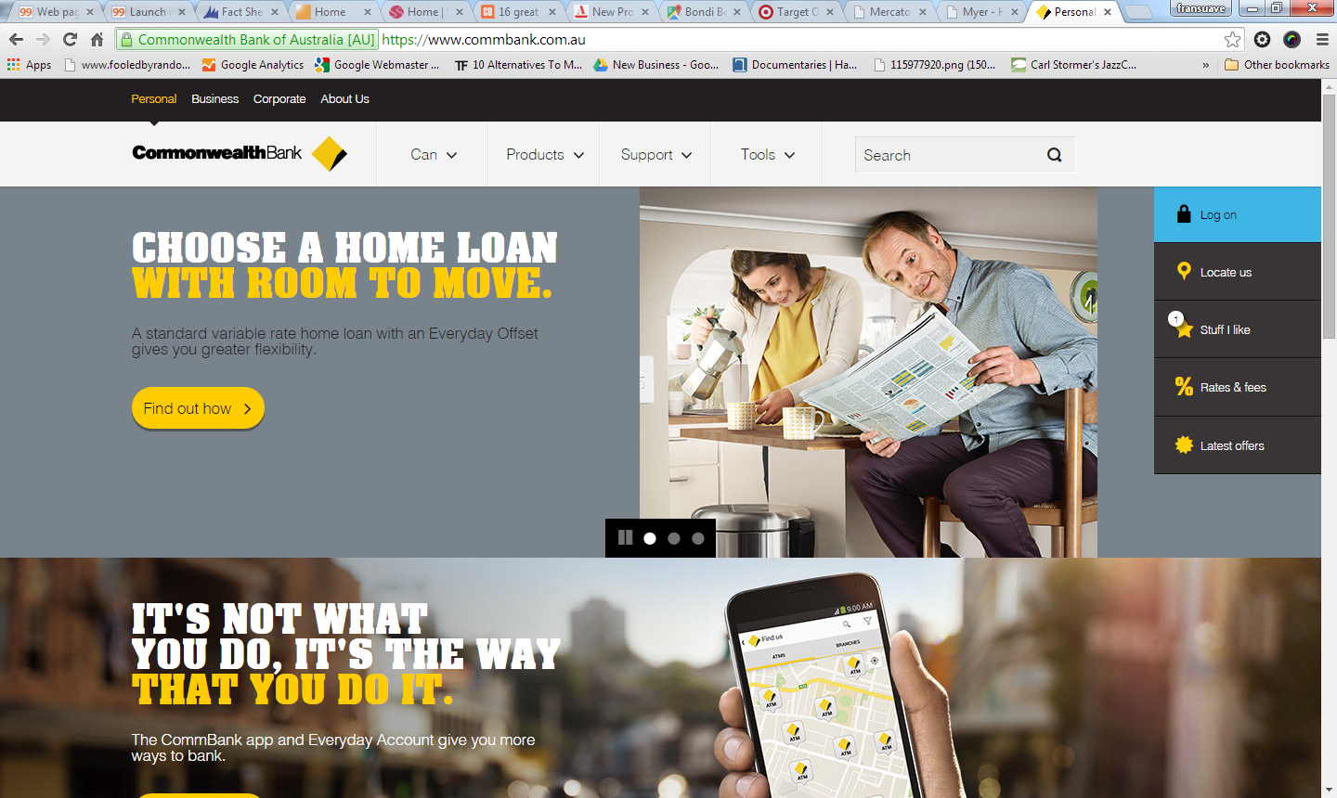

* Similar colour scheme to the Domus Logo